

**ASSIGNMENT- 6**

**STUDENT NAME:** ADITYA KUMAR **UID:** 22BCS16230

**BRANCH: CSE SECTION:** 22BCS_FL_IOT_603A

# SEMESTER: 6 DATE OF SUBMISSION: 18/3/25

**SUBJECT NAME:** AP LAB -2 **SUBJECT CODE:** 22CSP-351

# LEET CODE QUESTIONS:

108.[Convert Sorted Array to Binary Search Tree](https://leetcode.com/problems/convert-sorted-array-to-binary-search-tree/description/)

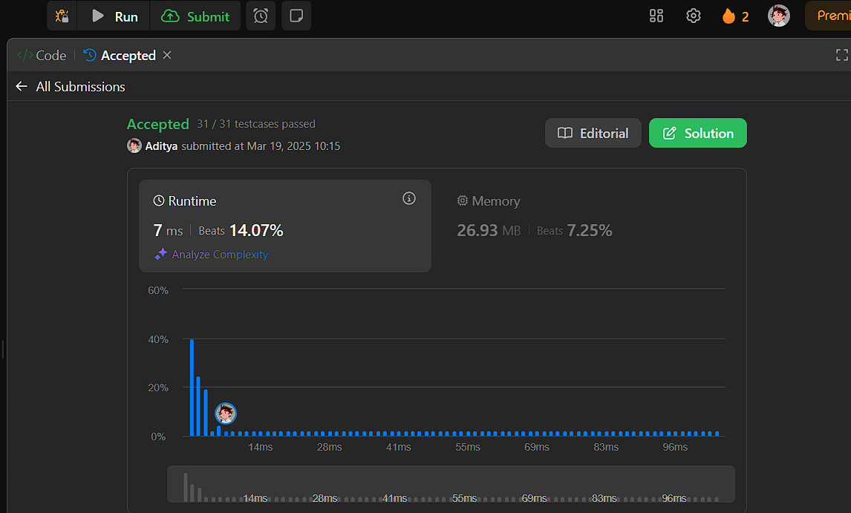

191.[Number of 1 Bits](https://leetcode.com/problems/number-of-1-bits/description/)

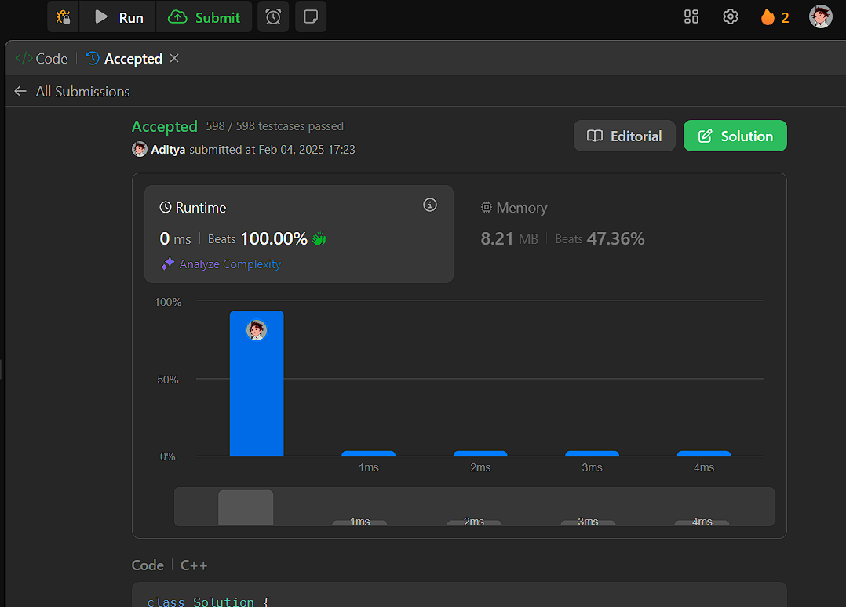

912.[Sort an Array](https://leetcode.com/problems/sort-an-array/description/)

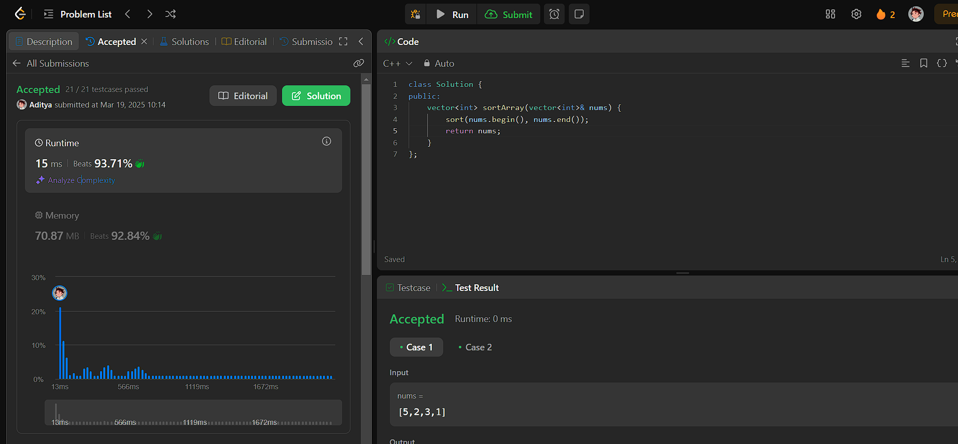

53.[Maximum Subarray](https://leetcode.com/problems/maximum-subarray/description/)

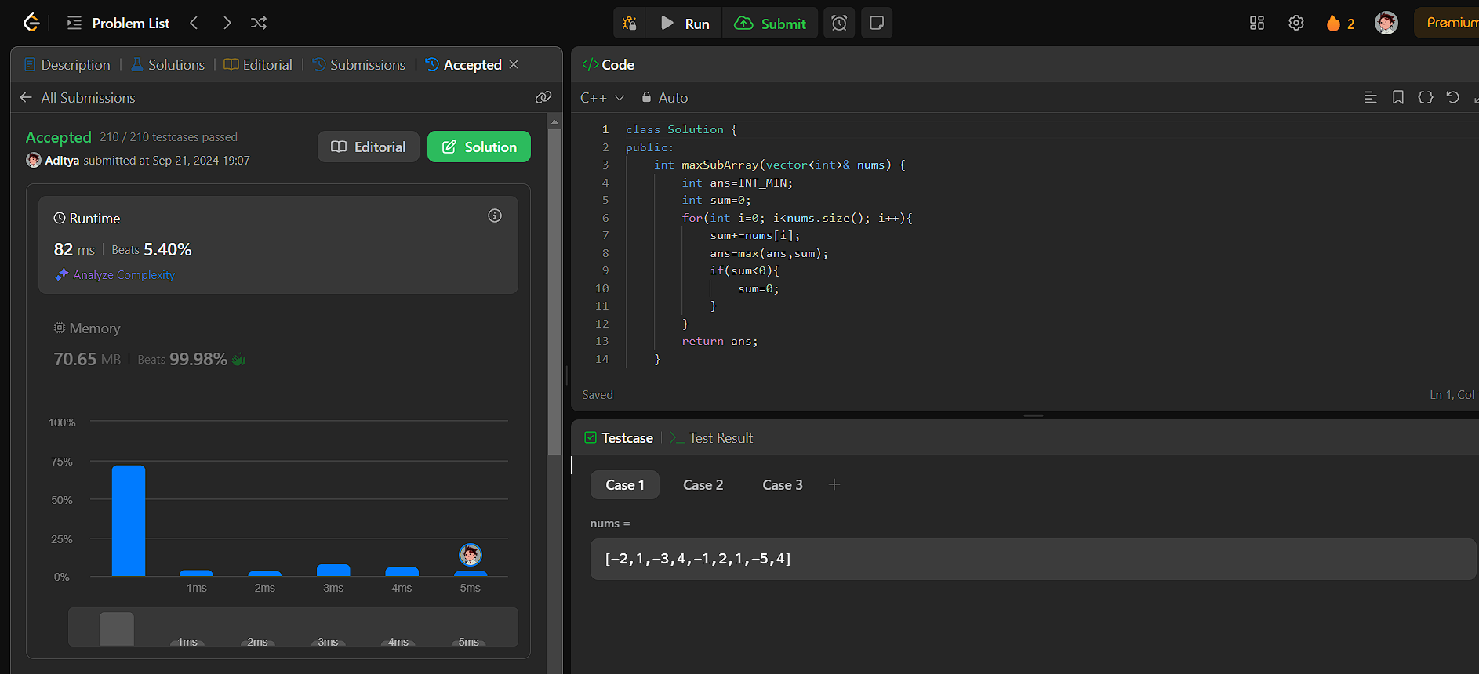

932.[Beautiful Array](https://leetcode.com/problems/beautiful-array/description/)

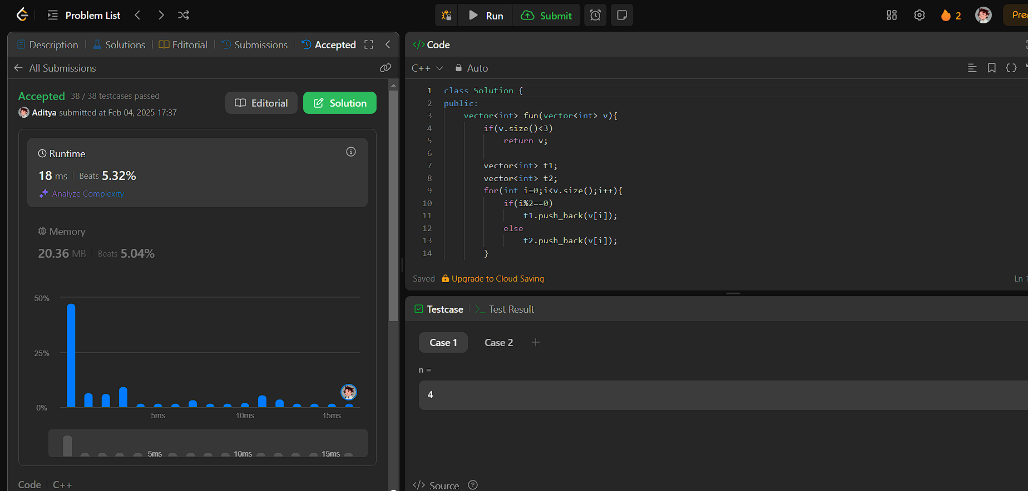

372.[Super Pow](https://leetcode.com/problems/super-pow/description/)

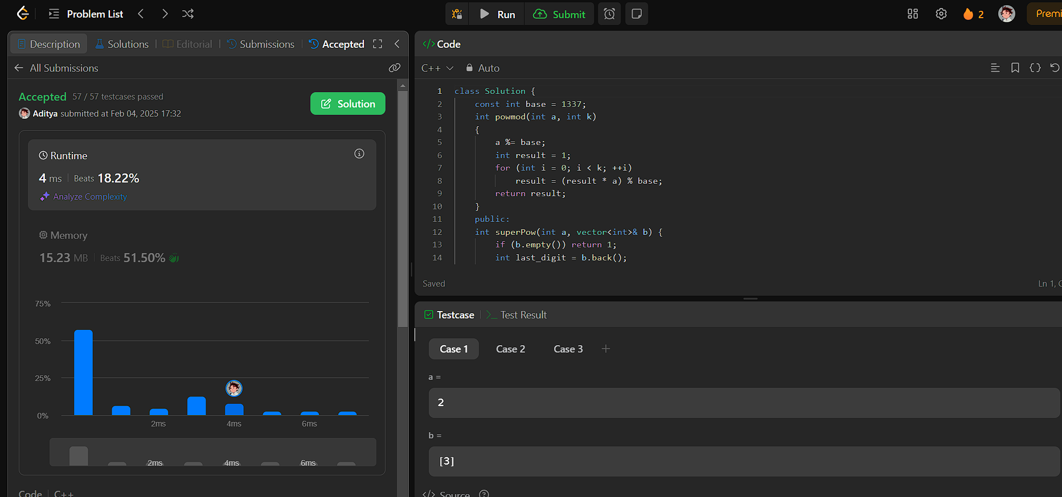

218.[The Skyline Problem](https://leetcode.com/problems/the-skyline-problem/description/)

